**Web design project 2019**

**- DIPLODOCUS BOOKS –**

Science in Web Technologies

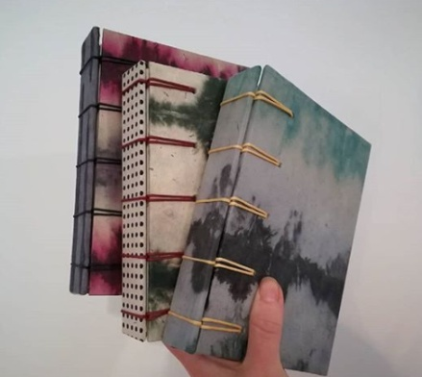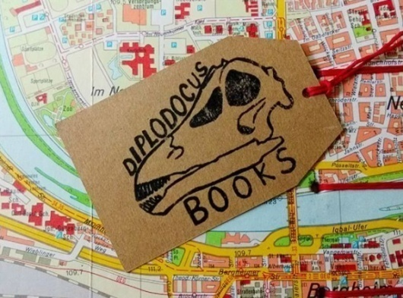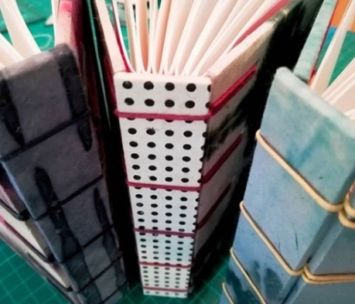

**Project report**

This document outlines the project concept, basic site plan and delivery strategy for **X18164030**/ *Steven Burke*. Firstly, I will outline the ideation process which led to the topic selection and the key considerations which led to my final decision.

**Topic Selection**

When choosing my topic, I looked at where goals for a business’s website could sit comfortably alongside the goals for this project brief.

Choosing a local start-up I believe is a great initial project as it gives the developer a clean slate, in that there may not be any brand image, call to action, mission statements etc. This will give the developer full control and direction of the project. Offering small businesses the advantage of owning an up to date website will enable them to improve CRO and CTR and showcase an overall professional online presence. These are the primary reasons for my topic selection.

**Primary goals:**

1. Showcase
2. Call to action
3. Lead Generation
4. Developing brand image
5. Creating online presence

I have made the decision to work with a creative enterprise as this will enable their creative assets to be displayed alongside their new brand image to link both and start to develop customer relationships.

The core idea for the site will allow the business showcase key elements of their offerings while creating a memorable experience for its visitors, leaving a lasting brand impression, communicated effectively across a relatively small number of pages, while staying responsive and dynamic on all platforms.

**Concept development:**

Researching the specific market was an initial step taken to give me an idea of the competition, their style, layout, navigation, copy and responsiveness. This will allow for an initial viewpoint of the market, its consumers and popular brand strategies.

**Workflow Diagram**

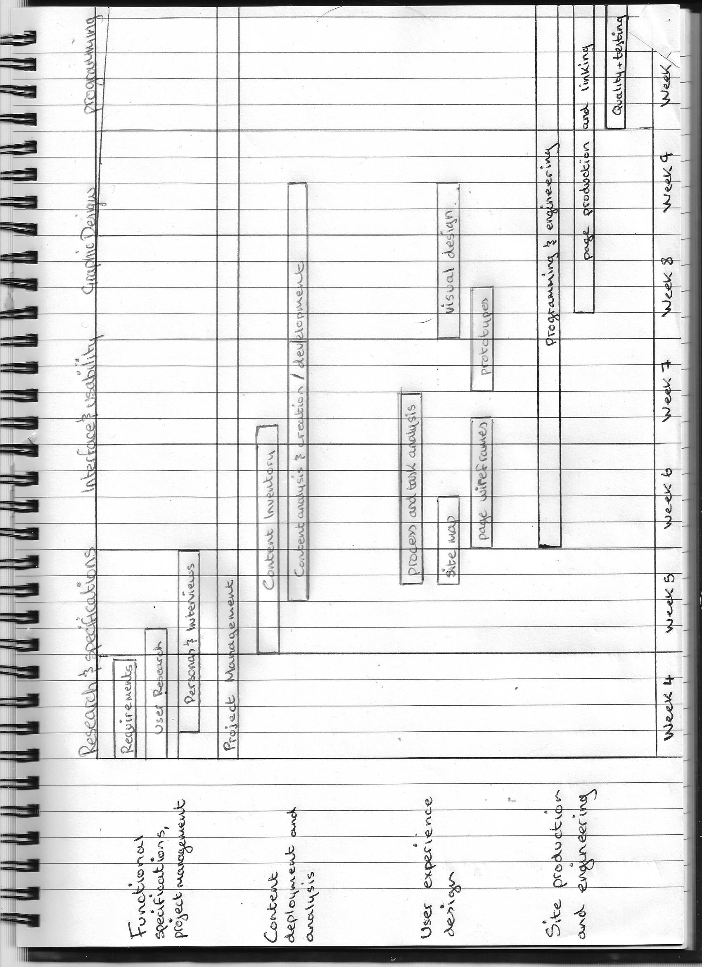

**Conclusion:**

I am hoping that my final product will adhere to design patterns, as well as brand, coding and accessibility standards. Aligning site goals and the project brief is a necessity so scheduling and time management are key for this project to succeed.

**Interview Questions & User Personas**

To gather relevant data for the design phase of the project I constructed a set of interview questions to explore user needs of the target and wider market.

I then examined the interview questions to develop archetypical user personas based on groupings and patterns found in my data.

Once this research was complete, to get a feel for how the user may interact with the site, I imagined using the website while pretending to be each user. This enabled me to extract additional information about a user by imagining their possible feedback.

“A persona is a fictional character that communicates the primary characteristics of a group of users, identified and selected as a key target through use of segmentation data, across the company in a usable and effective manner.

This ultimately enables the company to design the best user experience for its customers at all touchpoints, which is a key success factor in today’s business environment”.

The premise of user-centred design is that as knowledge of the user increases, so too does the likelihood of creating an effective website for them.

**Diplodocus Books Interview Questions**

1. What is your age?
2. What is your profession?
3. Where do you live?
4. How frequently do you read?
5. What are your favourite genres?
6. Have you ever purchased a custom book?
7. Do you think you received value for money?
8. Did you use online tools to find your product? If so what did you use
9. What social media networks do you use?
10. Is it easy to find testimonials/ recommendations?
11. What do you find frustrating about seeking recommendations online?
12. Do you find sites selling these products adequate?
13. If you had a magic wand and could change one thing about these sites, what would it be?

|  |  |  |  |  |
| --- | --- | --- | --- | --- |
| **QUESTION** | **PERSON1** | **PERSON2** | **PERSON3** | **PERSON4** |
| **1** | 18 | 32 | 26 | 47 |
| **2** | Student | Administrator | Tattoo artist | Mechanic |
| **3** | Slane, Meath | Ardee, Louth | Kingscourt, Cavan | Navan, Meath |
| **4** | Not often | Every day | Once/twice a week | When I find time |
| **5** | fashion magazines autobiographies | Romance novels, true crime | Art history, educational | History and cars |
| **6** | yes | yes | yes | yes |
| **7** | yes | no | yes | no |

|  |  |  |  |  |
| --- | --- | --- | --- | --- |
| **8** | Google app, pinterest, instagram | No, word of mouth | Google, facebook | Google |
| **9** | all | Facebook | Facebook, instagram, snapchat | none |
| **10** | yes | No – extremely difficult | No, I found it very hard | no |
| **11** | There are too many | Hard to categorize specifics | Info is too spread out | Can’t be trusted |
| **12** | No, very old school | They are okay | No, a lot of out-dated websites | Text is too small |
| **13** | Clearer contact info, with minimal clutter on the site | Update navigation, and give a contact info page | Having a star level and review system linked to each product would be handy | Bigger text with better contrast and multiple views of products |

**User Personas**

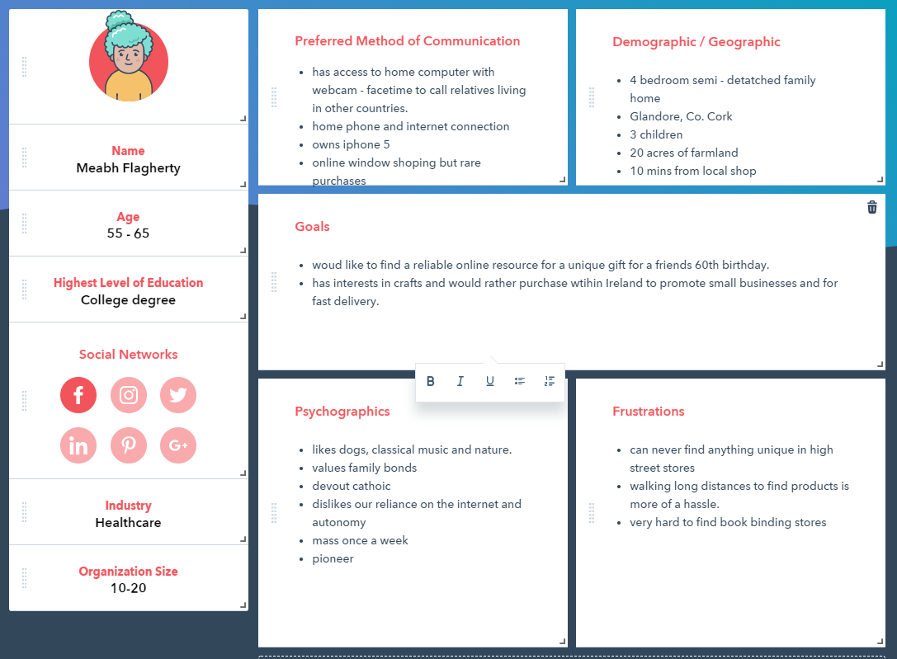

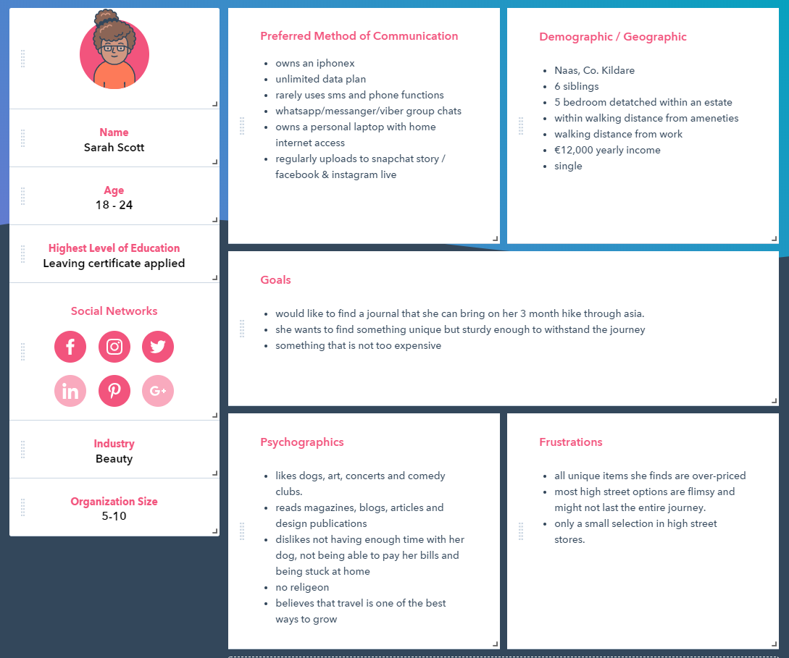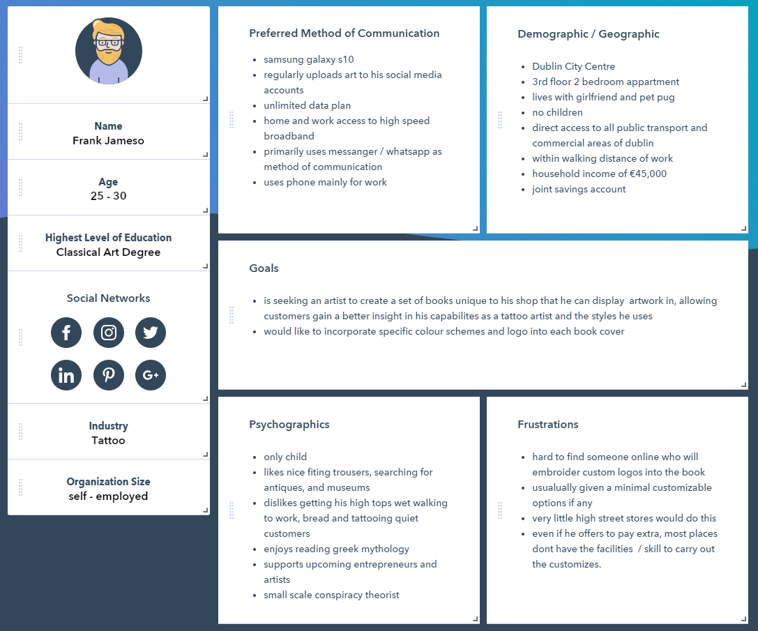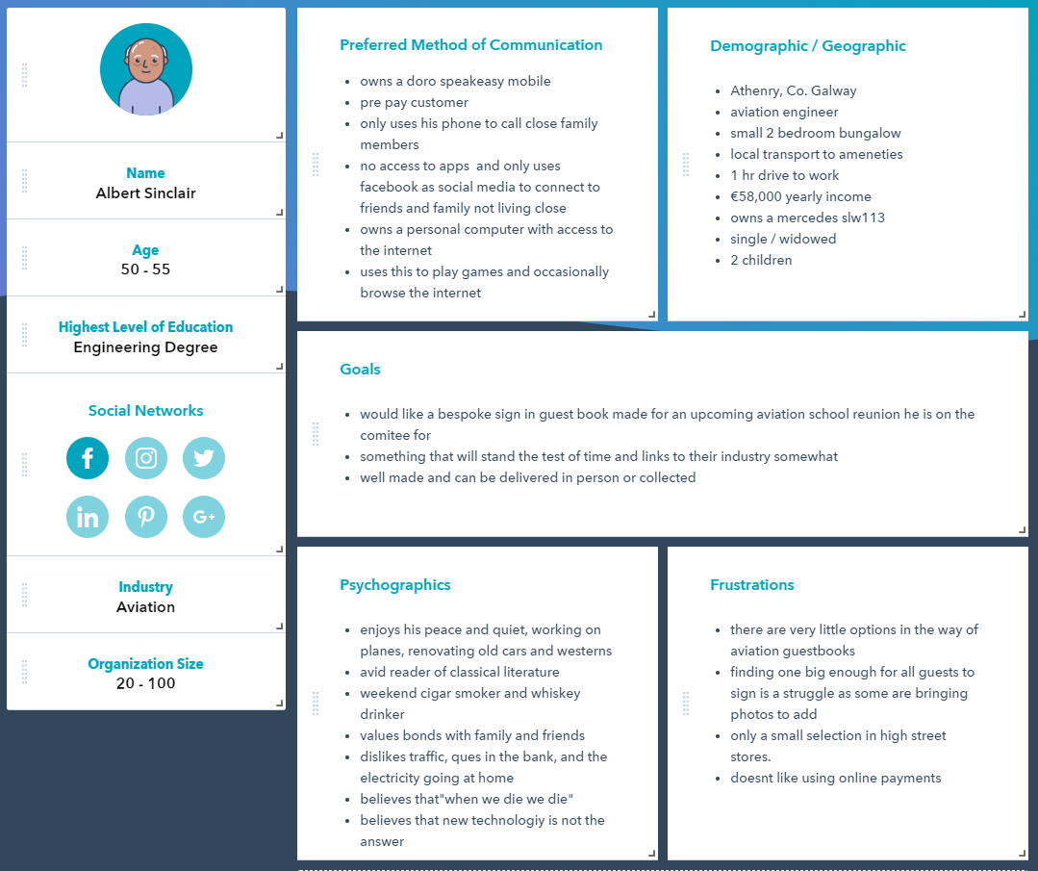

**Wireframes**

The website will adhere to standard web design conventions such as:

* + Navigation across the top of the site
  + Logo in top left
  + Footer containing social media links
  + 30% whitespace (CSS Box Model)

Homepage : index.html

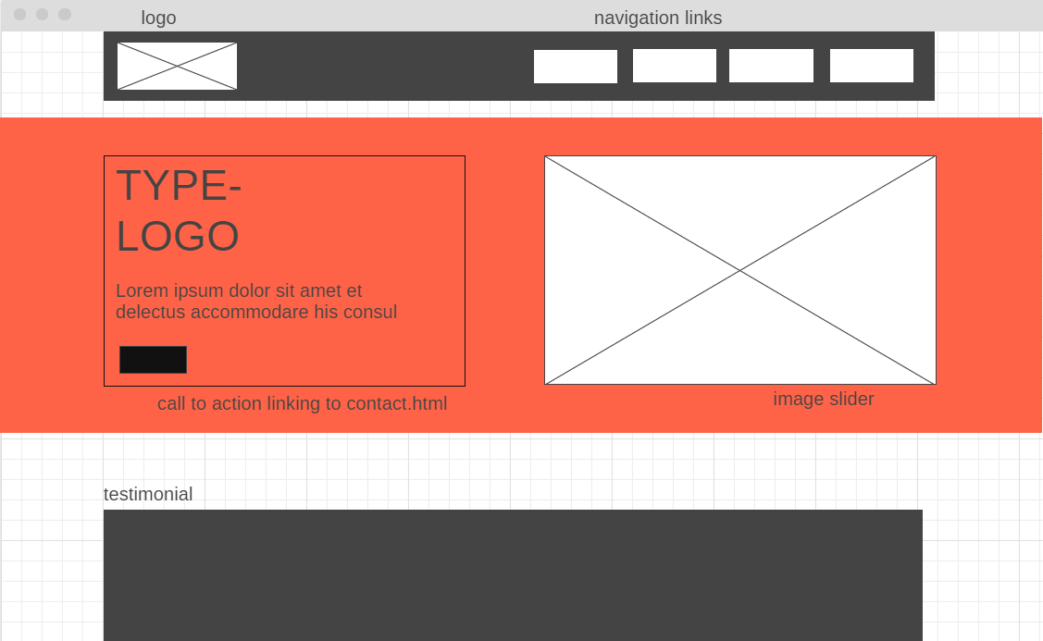

About us : about.html

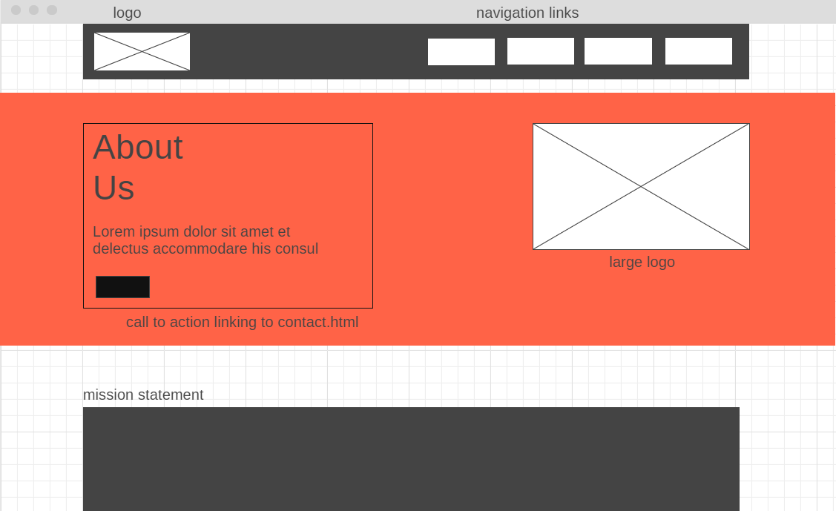

Contact : contact.html

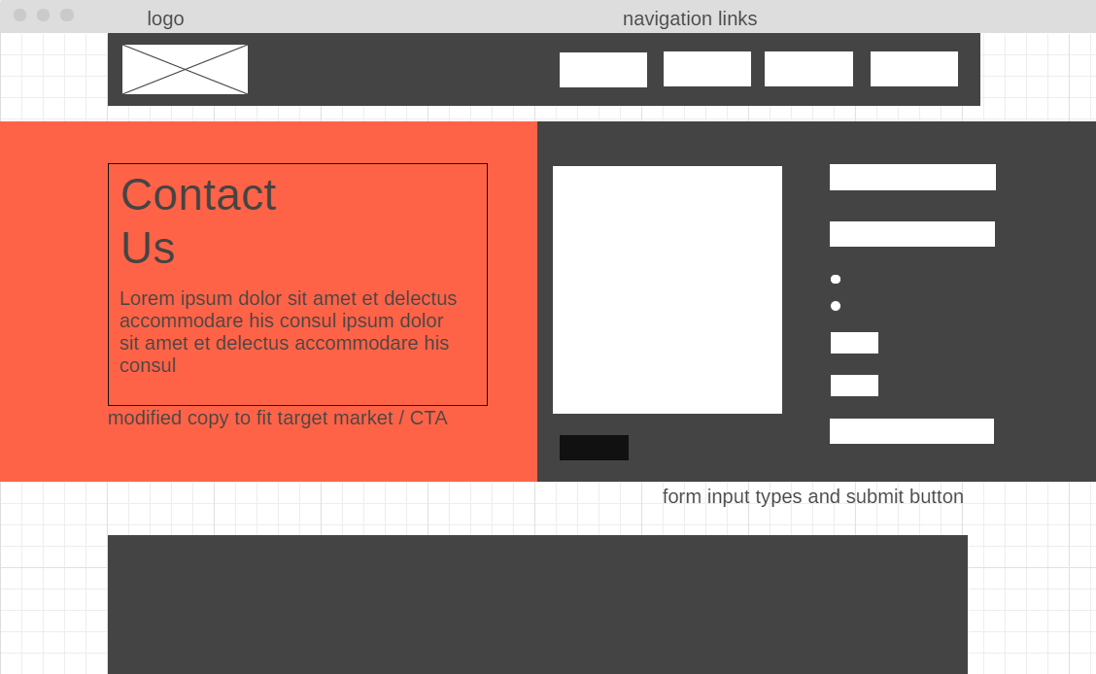

Footer : all.html

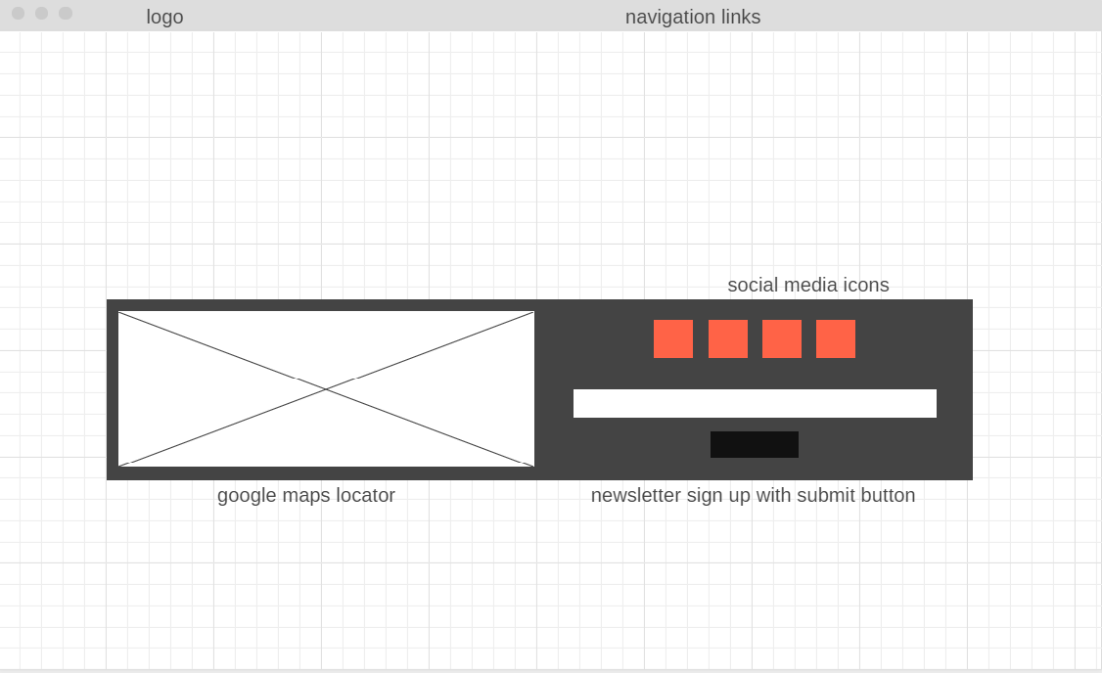

**Programming and Engineering**

**Javascript:**

* Validating form with if else statements from contact page and footer of homepage.
* Design implementation in photo slider and transition effect.
* External and internal Javascript.

**CSS:**

* Using vw for paragraphs along with responsive divs.
* Responsive images with max-width:100%;
* Using media queries to alter views for multiple devices.
* Hover, after, visible and current adding style to links allowing giving user knowledge
* Brand image and colour scheme incorporated on all pages.
* Form designed for easy accessibility and has auto complete turned on.

**Usability Testing**

**“Think Aloud” Methodology**

An implementation of the think aloud protocol was put into action nearing the end of the programming and engineering phase. This methodology is widely used for feedback in the testing phase of projects.

A version of the site was set up in a minimal staging room on a 24” screen. Three guests were invited to test the website. Upon arrival I supplied the testers with knowledge regarding *critical tasks* to perform and *“thinking aloud”.* A pen and paper were provided beside the keyboard area highlighting critical tasks and a section for reflection for the tester. The final section contained a questionnaire based on current test; this was to be filled out after the user has complete critical tasks.

**Critical tasks:**

1. Find the business phone number and location.
2. View a product.
3. Sign up for Newsletter.
4. Minimize screen to fill in and submit form.

**Questionnaire:**

**What is the purpose of the website? (ie. sales, informative, social media, etc)**  
I believe it’s for a small business used to showcase some of the crafts they produce. Although, if I had the option to buy then and there I would have.

**Is the website intended for anyone specific?**  
No I don’t believe so, it has friendly colours and round buttons.

**Was it easy to get to the contact form from the page you started on?**  
Yes, very clear navigation with lots of space. I liked how it highlighted each section to correspond with the cursor, the cursor change too was helpful.

**How did you find filling out the form in a mobile view?**

*Average, quite hard to touch text areas actually, and the text was small.*

**Did you find the phone number and location?**

Yes, very easy to find, contact page and the end of each page has a map.

**Was there something missing you were expecting to see?**  
It would be nice to see some more image views of the products and maybe a FAQ page about the company & products.

**Could you tell what the pages were about?**  
Yes, the colour contrast between the landing text and background made readability very easy.

**Was anything too obtrusive?**  
Nothing too obtrusive no, maybe the media icons a different colour or a little smaller

**Was anything too well hidden?**  
Nope, plenty of ways to navigate, similar style throughout too which made it all the easier.

**Any problems with the colour scheme?**  
I like the colours, they work well with, well everything, the text, logos, navigation,, buttons etc.

**Easy to read (both font style and size)?**  
Its ok, maybe different sizes like bold and italics would help readability in large text areas but I like the subtle use of different fonts.

**How did you find the layout of the site?**  
*Nice and clear. Found everything I expected on the different pages in terms of info.*

**How intuitive and helpful is the navigation system?**  
The navigation system is quite basic but clear. Links within the text and buttons to gain access to contact page and sign up form are good.

**What would encourage you to return to this site in the future?**  
An online shop, offers information, social media updates, multiple photo views.

**Name your three favourite things about the site, and your three least favourite**  
Favourites:

mobile friendly, easy navigation, simple & clear layout and colour scheme

Least favourite:

no products page to view specific items or prices, not enough business information, how the nav section changes image on each page, unnecessary i think.

Conclusion

I believe that project goals were met and aligned perfectly with brief. By the end of design and implementation I was able to correctly navigate throughout the website, allowing me to showcase all assets to give maximum experience for its visitors, leaving a lasting brand impression, communicated effectively across a relatively small number of pages, while staying responsive and dynamic on all platforms.

Design standards were adhered to and kept in line with Jacob Nielson ten heuristics for user interface design.